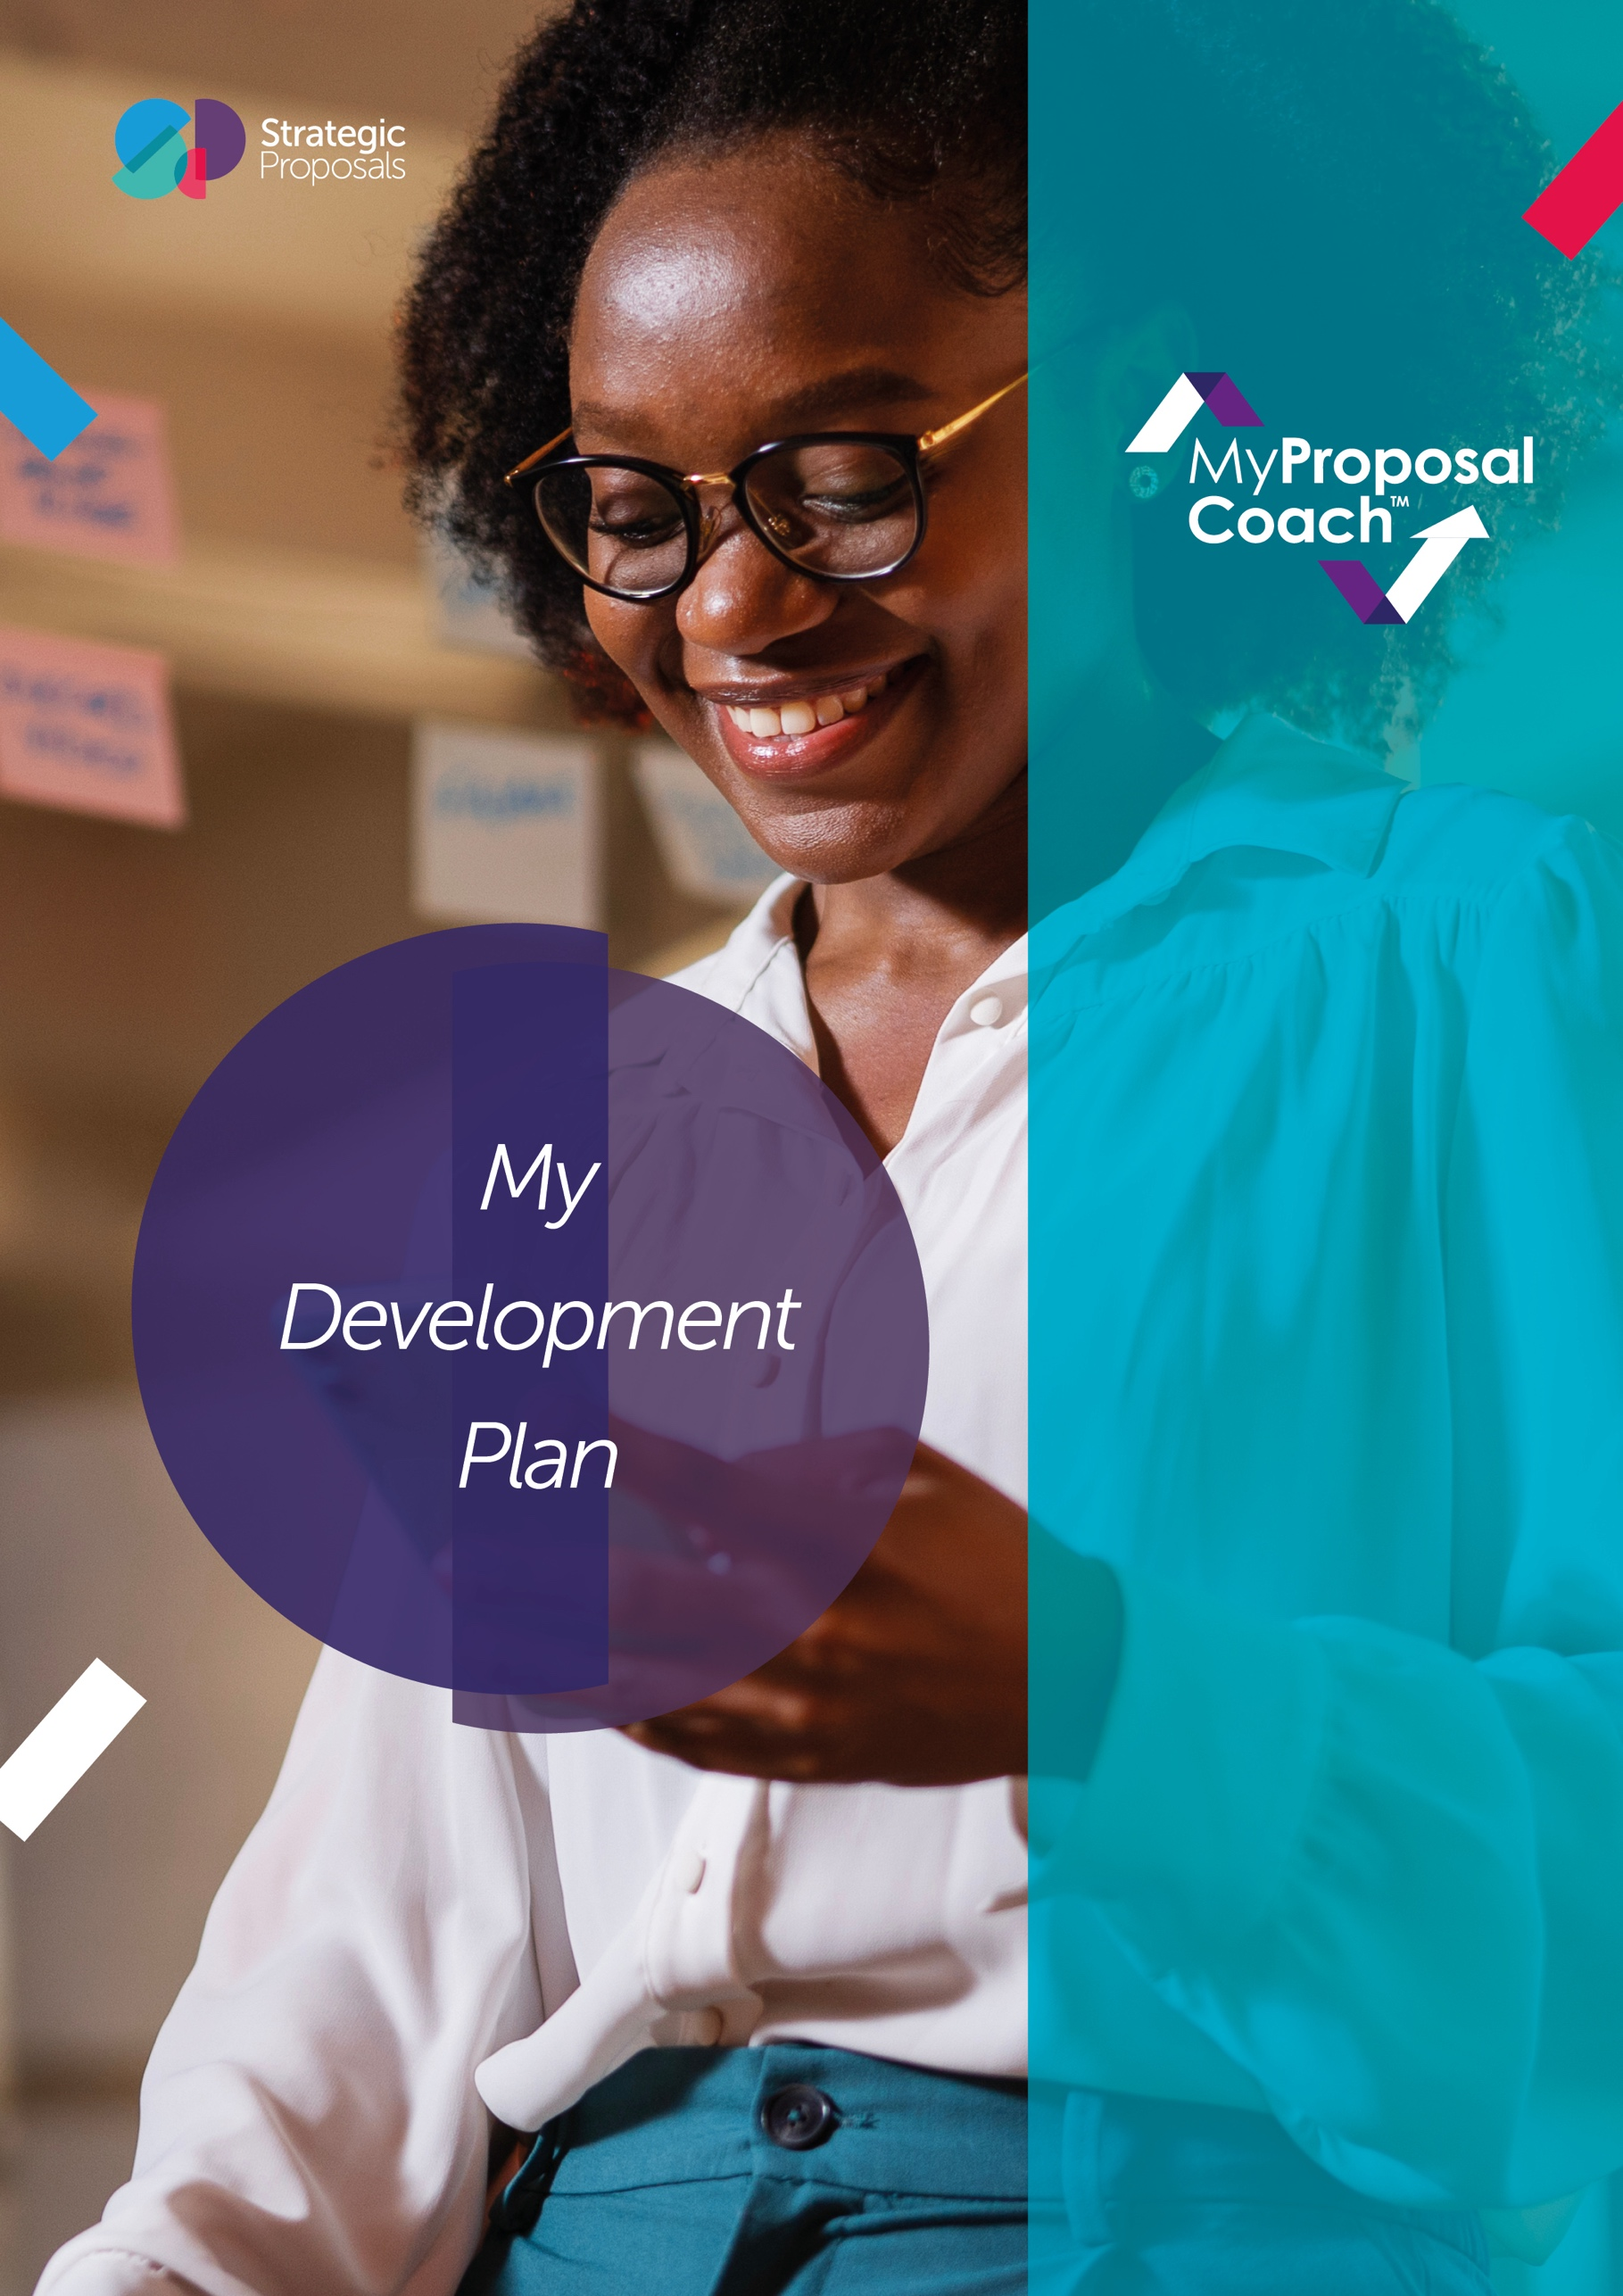
Introduction and My Plan
Thanks for completing the MPC. This document is designed to help you make the most out of the tool. It contains all the categories at a high level that you need to be a proposal guru. The table below is a template for you to use to track your progress. There’s space for objectives and goals under each competency area covered in the remaining sections of this document.
Date MPC completed | My rating | Proposal certification held
Table entry font (use this)

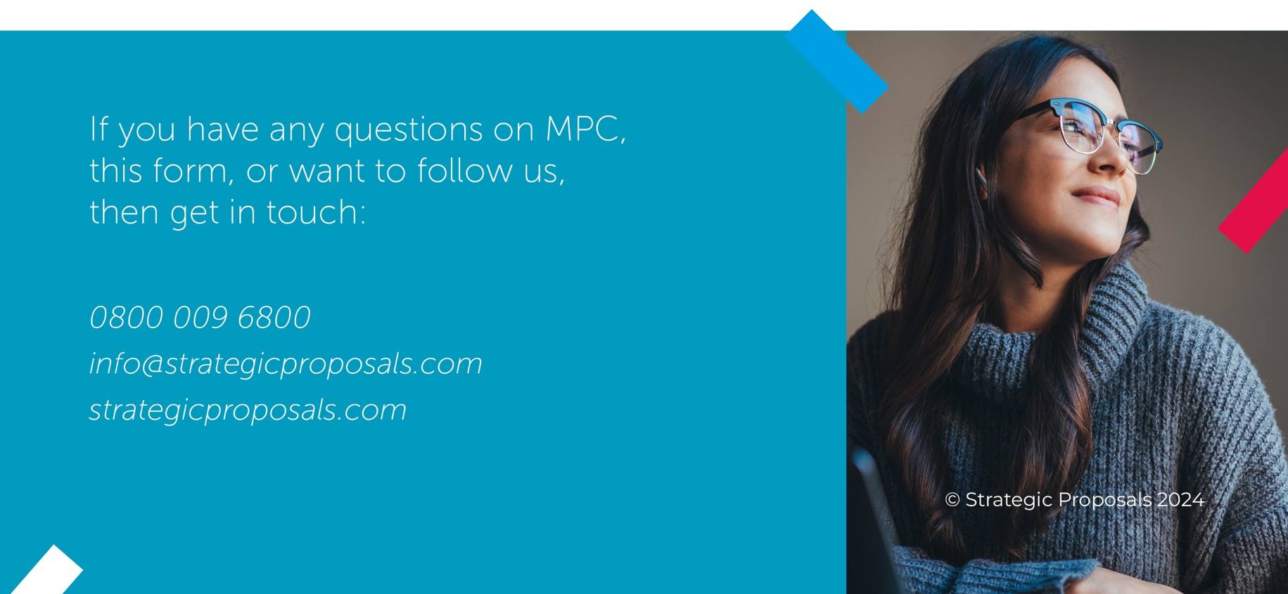
My plan
Capture your key objectives here. Note that there's space to write down more specific ideas, next.
Objectives | Next 4 weeks | 1 to 3 months | 4 to 6 months | 7 to 12 months

Support I need to develop my skills
Notes on my progress

Development ideas
The simplest way to develop your skills is by speaking to someone who you know already possesses those skills. Find someone willing to coach you in the areas where you need to develop and start talking to them about what they do, why and how.
- Have a look at the results page, that you will have received a link to – this includes a really good reading list for you to pick from.
- Listen to our webinars and read other free content in the resource centre on our website.
- Purchase our pre-recorded online training programme ‘Proposal Essentials’ – available via our website.
- Follow us on LinkedIn.
- Study the APMP’s Body of Knowledge.
- Get inspiration from our tailored on-site and virtual training courses. See the training area of our website for more details.
- Look in to our 1:1 coaching packages, also on the website.
If you can't find what you need or just want to speak to one of our experts, then email us at info@strategicproposals.com.

Your plan to develop your skills
Categories to focus on:
Category | Key reason chosen

KEY CATEGORIES
Proposal management best practice
Always understand and implement the proposal best practices associated with your role! Your understanding of your own processes should be absolute – why do you do things when you do them? Who should be doing what? If you’re unclear, discuss it with a colleague.
Perhaps asking more experienced people in your organisation what they think good looks like would be helpful. Discuss it with them – not just bid and proposal people. Or you could find someone who is a champion of best practice and ask them about their approach and what has worked well for them.
Opportunity identification (engagement)
Your goal is to understand how to identify opportunities and how they’re moved into the proposal process. Take the time to get to grips with your own organisation’s process as opportunities move from a sales funnel of leads into becoming a real opportunity. Perhaps speak to senior and experienced sales and business development people who can take you through this if it’s not clear.
Getting involved in early opportunity stage discussions is key if you aren’t already. Ask questions on what the strategy and tactics with the customer are to help you build on your knowledge. Planning ahead more for the opportunities that are forecast to come your way will help you decide what you need to put together a winning bid.
Opportunity evaluation (qualification)
It’s crucial to make sure that you're always pursuing the right opportunities. You need to understand the principles of qualification and the core questions that you should be asking on each opportunity: Is it real? Can you do it? Do we want it? Can we win it?
Make sure you understand your own processes – perhaps measure them against best practice in the “off to a flying start” section of our free-of-charge Proposal Benchmarker tool. And make sure you understand why your organisation has put these processes in place.
Pre-proposal planning
Your goal is to be able to know what information is required to develop a compelling proposal and to understand how to do that. But there’s more to it than that. In the pre-proposal phase, it’s also about understanding how you can bring your proposal skills to influence a proactive proposal / renewal strategy.
Make sure you’re as organised as you can be in the immediate time before the RFP is due to land. And in that period, understand when you can help with influencing the customer or prospect, creating proactive proposals and pitches, and gathering the information needed to develop a great proposal.
Be clear on why it’s important to prepare – people will need convincing, so have your story straight and clear.
Proposal project management
You need to ensure your skillset allows you to properly manage, efficiently run, and effectively deliver each proposal project.
Start by looking at the plans for successful proposal projects that you’ve created, or your colleagues have. Review those and understand why they were successful. What key interventions were made and when? Make sure you have a clear plan – write it down and share it with the team you’re working with on each opportunity. Then make sure that you get active with how you manage the process – interacting with your team members on a regular basis inside and outside of the planned interventions. You’ll also need to develop and hone your delegation skills for when you have to allocate actions to team members (remember that all actions should follow the SMART principles).
If you have strong communication and interpersonal skills, the ability to negotiate and resolve conflicts quickly and can build commitment within the team, then you’ll be doing well. Communication skills are clearly essential – the main ones to master are:
- Showing respect
- Active listening
- Using positive body language
- Asking questions
- Following email etiquette
- Being open minded
- Giving feedback.
Proposal strategy development
For each of your proposals, you need to create a winning proposal strategy that includes ensuring you facilitate the creation of a compelling story, a list of unique themes, a compliant response structure and a compliant solution. This also includes making sure that the strategy is reflected in the design of your proposals and pitches, as you have the skills to contribute to the wordsmithing of strategy and theme statements.
Learning reviews
The ability to learn from your work is fundamental to improving skills and approach. So, it’s important for you, as well as your organisation. You need to make sure that learning reviews are completed in the right way for your organisations. It’s crucial that you learn lessons from both wins and losses by facilitating and capturing actionable recommendations from internal and external learning reviews.
Sales and capture awareness
There are various facets involved in winning opportunities that extend much earlier in the opportunity process and into business development and capture. Being aware of how these parts of the overall sales process impact the pre-proposal, proposal, presentation, and post-proposal activities is important to understand.
Firstly, for all those working on proposals, you need to understand and make sure that the inputs to the proposal process from sales and account management are joined up, through being cognisant of the latest sales and capture techniques. And you need to know how the proposal process fits within the organisation's overall sales (or capture) and bid processes.
On top of all this, you must also have a clear understanding of the respective roles of the salesperson, business development manager, account manager, bid/capture/engagement manager, and proposal manager. And you need
a high-level knowledge of the key principles associated with core areas of subject matter expertise within the bid, including commercial (Ts and Cs), pricing, project/implementation management and solutions design/architecting. Having extensive knowledge of best practice sales, capture, bid management processes and project plans is imperative.
Personal credibility and impact
To be really good in a proposal environment where you’re constantly working in teams of different people, it’s very important that you quickly establish credibility with your team. To do this, you need to be confident in your own area of expertise – being able to demonstrate your experience of winning work and knowledge of best practice. With this in your back pocket you can then express your own opinions clearly and give advice on strategy and approach. Backing up your points with clear examples or views on outcomes is important to establishing authority. Then you’ll be on your way to being a trusted advisor on proposals and related topics.
Personal time management
Working in proposals, often time pressured, can be stressful. It’s important to know how to achieve a healthy life/work balance, so that you’re able to deal with these pressures. You’ll often find yourself working on multiple proposals, larger proposal development, and other business projects concurrently, so you need to be able to manage these, prioritise your time, and give sufficient attention to each proposal at the correct time. You need to know how to adapt, so that you deliver the highest priority actions to the right levels of quality and outcome. Not that easy to master all of these things, right?
If you need help dealing with the complexity and the ambiguity associated with proposals, then you might find our “Mental health and wellbeing in the proposal industry” webinar recording useful – find this in the resource centre on our website.
To be good at personal time management requires several skills. These include ones that we’ve highlighted as key skills so far such as prioritising, delegation, decision making, goal setting, multi-tasking, problem solving, strategic thinking, planning, and scheduling. If we were to summarise the core things that make for a strong proposal person then it would be to get more active with your time management. Some of these things are basic and common sense – but as we know, there’s a tendency for this not to be that common!
Proposal tools
Knowing how to build and use proposal tools is a key part of improving proposal development efficiency and effectiveness.
Tools for me to research:
- .
- .
- .
- .
- .

